1. INTRODUCTION TO QUANTUM MECHANICS

# **The Need for a New Theory**

At the end of the 19th century, **Classical Physics** (CP) (based on Newton’s Laws of Motion + Maxwell’s Electromagnetic theory that unified existing knowledge of electricity, magnetism and waves elegantly) was failing in several areas. For example, **CP predicts absurd things such as:**

* All bodies at Temperatures (T) > 0 Kelvin (K) **radiate an infinite amount of energy!**
* Kinetic Energy (KE) of electrons in **Photoelectric Effect** experiments ∝ light intensity (and not on the frequency of the incoming radiation) and, very importantly for chemistry,
* An **unstable atom** with electrons spiraling into the nucleus while radiating energy.

Whereas, **CP** **did not predict:**

* **Diffraction of electrons** by a crystalline solid and
* **Line spectra** emitted from atoms or small molecules.

We need to be in an understandable world, so that based on this understanding we can properly view matter, develop new theories, predict new things and act on our understanding by developing new disciplines, constructing new instruments {e.g., quantum computers & quantum cascade lasers, cell phones & smart watches, NMR & MRI (magnetic resonance imaging)}, etc.

At start of 20th century, however, many phenomena at the atomic level were **not explainable by CP!!!**

Some branches of Chemistry as a discipline explain the **macroscopic behavior** of reacting molecules, but comprehending this behavior depends on an understanding of chemistry at the molecular level; that level of understanding **could not be provided by CP**.

***Chemistry at our level should not be simply understood in terms of a cooking experiment ☹!***

## Requirements of a theory

* **Science theories gain acceptance** if they can make the world around us better understood. A key test of a theory is in **explaining the results of a new experiment** – if it can, we gain greater confidence in the model underlining the theory; if it can’t, the model needs to be modified or scrapped (discarded) entirely.
* At the end of the 19th century, many scientists believed that CP had little left to achieve.
* BUT in fact trouble was brewing because **CP could not account for natural phenomena at the newly accessible (at that time) atomic level**.

Consequently, a new physical model was needed to describe the behavior of atoms and molecules at the microscopic level: the new theory would be termed **Quantum Mechanics** **(QM)**. Spring 2021**Some basic tenets of QM**

* ***Quantization of energy levels***– a central feature of QM’ics. At the atomic level, energy is not a continuous variable – it comes in discrete amounts called **quanta**.
* ***Wave-particle duality of nature*** – another central feature of QM’ics. At the atomic level, **light** waves have observable **particle-like** character and **small entities** (like electrons) have observable **wave-like character**.

### Consequences of Quantum Mechanics

In a sense, we are everyday users of QM’ics – the stability of atoms is taken for granted; the operation of bar-code scanners and CD players with their solid-state lasers is taken for granted; the integrated circuits in our computers, laptops, cell phones, i-Pads, calculators, etc. are taken for granted; IR and UV-Vis spectroscopies are taken for granted; Nuclear Magnetic Resonance imagining as a probe of internal organs has become a frequently used tool in medicine; etc.

These phenomena depend for their explanation on QM’ics. The invention of many emerging technologies (e.g., quantum microphones, nano-electronics, X-ray lasers) all depend on QM’ics.

**Some phenomena in early 1900’s unexplained by CP** (more details given in #2)

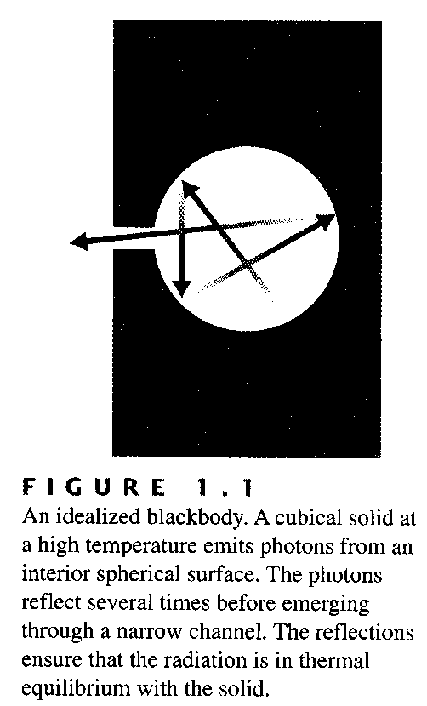**1. Blackbody Radiation**

In a *Blackbody Radiator*, E-M photons are emitted from the interior of a heated solid through a small spherical hole; photons reflect several times before emerging via the narrow channel thus ensuring the emitted radiation is in thermal equilibrium with the heated solid.

CP can be used to predict the *frequency* of light that is emitted and the *relative magnitude* of that light as a function of temperature. Expressed as a *spectral density*, that prediction (from CP) is



where ρ(ν, T) [“rho”] is the spectral density as a function of ν [“nu”] and Temperature [≡ energy at frequency ν per unit volume per unit frequency stored in the EM field of the Blackbody Radiator], c is the speed of light, and  is the average energy of an oscillating dipole in the solid of the blackbody. Units of spectral density, [ρ], are

; the units can be derived from the right side of the above equation as shown here*: 

* ρ(ν,T) equation results from considering a Blackbody is a collection of oscillating electric dipoles of heated atomic nuclei with their electrons serving as the source of radiated energy.
* dν occurs on both sides of the equation because we are referring to the energy density observed within the frequency interval dν centered at frequency value ν.
* 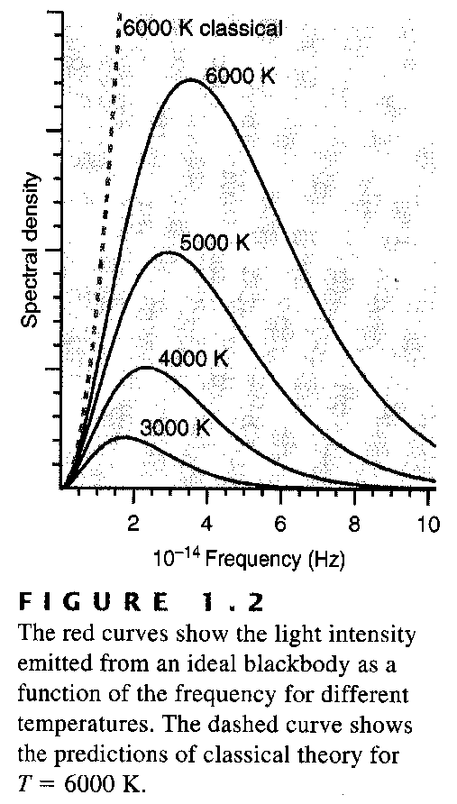CP predicts the average energy of the dipole oscillator is related to T as  = kBT where kB is Boltzmann constant, 1.380649 × 10-23 J K-1 (considered exact) so

.

* However, this CP Equation actually predicts that at any temperature T, the spectral density ρ(ν, T) continues to increase with ν (see diagram below) which is an absurd outcome.

**Experimentally,** a **much different pattern** is observed:

* The **ρ(ν, T) vs. ν plot** has a **peak which shifts to higher ν as T is increased** (just as with an electrical heater where as the temperature increases, the color of the heater changes from red to yellow to white).
* CP prediction for T = 6000 K (see dotted line) is close to what is observed experimentally at low ν, (see plot) but the CP prediction continues to increase at higher ν; since the area under the ρ(ν,T) vs. ν plot gives the total energy per unit volume, ***CP*** predicts a ***blackbody will emit an infinite amount of energy* at all T’s > 0 K** – this is *clearly impossible!*

### An Explanation for Blackbody Radiation – the new physics

***Max Planck*** provided the initial insight that led to an understanding of Blackbody Radiation.

CP & Max Planck: Blackbody Radiation is due to vibration of electric dipoles that emit radiation at the frequency of their oscillation. Experiment showed radiation at high frequency was absent so **Planck** postulated that the **emitted energy radiated** by the dipoles is **directly proportional to (∝) the frequency ν [nu], i.e., E = nνh** where **h** is **Planck’s constant** (6.62607015 × 10-34 {exact} J s) and **n** is 0 or a +ve integer, **n = 0, 1, 2, .....**

i.e., **Planck** had postulated **energy** **is** ***quantized*** (though **ν, frequency,** itself is continuous).

**This started a new era in physics**. According to CP, energy is a continuous quantity, but Planck’s equation specifies that the **energy radiated by a bLACKBODY is not continuous** - it can take on only a discrete set of values for each frequency, ν.

Using this postulate, **Planck derived a new equation for the spectral density:**

,

**by using a new expression for the average energy of an oscillator given by**:



This **exactly produced the experimentally observed ρ(ν, T) vs. ν plot** (Assignment problem).

We now can see how this result ties in with some features predicted by the CP equation. **At high T** where hν/kBT << 1, the exponential function can be expanded in a Taylor McLaurin series as:

ex = 1 + x + x2/2! + x3/3! + ......

Thus we can write:

 as predicted by CP. **But at low T** where hν/kBT >>1, the denominator becomes very large &  → 0, in keeping with the observations.

**Planck** had “explained” Blackbody Radiation with the assumption that the energy of the emitted radiation came in discrete packets called **quanta; he had uncovered a new fact of nature!**

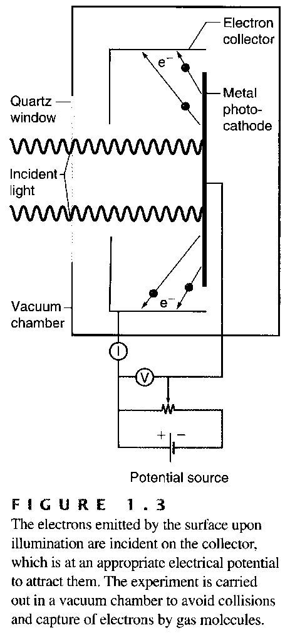**2. Photoelectric Effect**

**Experiment Setup:** Radiation is directed onto a Metal photo-cathode which consequently ejects electrons (e¯) which are accumulated by an Electron collector – see diagram →.

**CP predictions:**

(a) Light is absorbed by many electrons in the solid.

(b) Electrons are emitted for all frequencies, ν, of radiation provided the light intensity is high enough.

(c) **Kinetic Energy (KE) of emitted electrons will increase** as the **intensity of the light is increased**.

**Experimental observations:**

(a) Number (#) of emitted electrons ∝ light intensity but

(b) the **KE of emitted electrons is independent of the light intensity**.

(c) **No electrons are emitted unless the ν of the radiation exceeds a threshold value (νo)** where νo depends on the particular metal (it is lowest for easily ionizable metals such as Cs).

(d) **Provided the frequency of the light is high enough, electrons are still emitted even at low light intensity** and even when the entire metal plate gets barely enough electromagnetic radiation energy to emit a single electron based on energy conservation considerations.

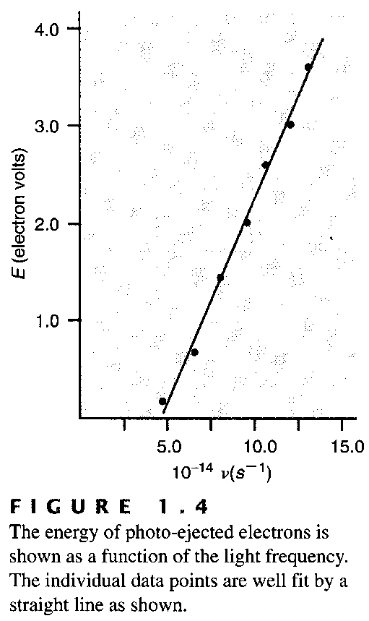**Experimentally**, it is found that the Kinetic Energy is

**KEelectrons = βν – φ**

where ν is the frequency,β [beta] and φ [phi] are constants for a particular metal, and parameter φ is called the Work Function (≡ binding energy of the electron in the solid).

* Albert Einstein (1905) was able to explain the PE Effect if he assumed that the energy of the light was proportional to its frequency, ν, i.e., that E = βν where β is a constant.
* From an examination of the KEelectrons vs. ν plot, **⇒** parameter β can be determined. **(From what? A question for you to answer NOW.)**
  + What is **β**?; it is found to be Planck’s constant **h**!

**That is, once again, the energy of the light = E = hν.**

* Gives direct support to Planck’s hypothesis and earned Einstein a Nobel Prize in Physics (even though he initially was a skeptic as far as QM’ics was concerned!).
* Observation that even very low intensity light can lead to photo-emission shows the absorbed light is not distributed uniformly over the entire surface; thus, we can conclude that all the incident light can be concentrated in a single electron excitation **→ termed the photon.**
* A photon ≡ a spatially localized packet of light **⇒** conclude that light can exhibit **particle-like character** under some circumstances. This led to the **3rd fundamental experiment** which showed that the reverse also applies: particles also can exhibit **wave-like character**.

**3. Diffraction of electrons by a crystalline solid**

* 1st suggested by **deBroglie** (1924): he related momentum (p) and wavelength (λ) for light, as



where the momentum of the particles, p = mv (m is the mass and v is the velocity).

* Proposition was confirmed in 1927 by the Davisson and Germer’s (D & G) electron diffraction experiment.
* We know (1st year Physics), that to observe diffraction, the width of the spaces in a diffraction grating must be on the order of the wavelength of the light so if the particle is an electron, an ideal candidate is a crystalline solid where the spacing between atoms will be small enough.
* In their classic experiment, D & G diffracted electrons from crystalline NiO to verify the deBroglie relation (and since that time, diffraction of He atoms and of H2 molecules from crystalline surfaces has been observed – see Text). Result thus suggests that there should be a wave equation that applies to particles too.

**Double-Slit Experiment (see text)**

To further illustrate the wave-like character of particles, Text describes a double-slit experiment: electrons are directed onto a double slit **→ result can be interpreted as a diffraction pattern resulting from the electron wave function emanating from the source (≡ an electron gun).**

**4. Atomic Spectra**

**Perhaps the most direct evidence for the need for energy quantization** comes from the lines **observed in atomic spectra** (e.g., from excited atoms in a plasma discharge).

The picture of the atom that had emerged by the year 1910 was of a positive (+ve) charge contained in a small volume called the nucleus surrounded by a negatively (–vely) charged electrons that occupied a much greater volume that was centered at the nucleus.

* However, this **picture is untenable according to CP!!!**
  + **According to CP,** an electron orbiting the nucleus is constantly accelerating and must be radiating energy according to EM theory: thus, as it continually radiated away all its KE, the **electron would** **spiral into the nucleus!** **Clearly this does not happen!**
  + It was known from the 1890’s that a gas (e.g., H2) could emit light from an electrical discharge – and that **line spectra** would appear if this light is dispersed. This light is only observed at certain discrete wavelengths – i.e., it is **quantized**.
  + This was not understandable from CP which held that only **band spectra** could be observed.
* Furthermore, what was more baffling at the time, was that some simple (?) relationships had been derived that accounted for the frequencies observed in the emission spectra.
  + [We now would explain atomic spectra by saying that the atom in the plasma discharge is excited from its ground state energy level to a higher energy state and when the electron relaxes to the lower energy state it emits light at a corresponding discrete frequency].
* **For the atomic Hydrogen spectrum**, for example, all the lines could be accounted for by an equation of the form

$$\bar{ν}(cm^{-1})=\frac{1}{λ(cm)}=R_{H}(cm^{-1})\left[\frac{1}{n_{1}^{2}}-\frac{1}{n_{2}^{2}}\right]$$

where ***RH*** is a constant (109,677.58341±0.00001 cm-1 for H)* & the ***n’s*** are integers with ***n2 > n1***. A particular **series of lines** are observed when **n1 is the same constant integer**. Note the units.

* The constant given in Tables of Physical Constants (e.g., NIST) is that for R∞, which is the value for a “hydrogen-like element considered as having a single electron.” The NIST current value for R∞ (CODATA value published in 2018) is 10,973,731.568160(21) cm-1; [it was 10973731.568508(65) in 2014 CODATA]. *That given here for RH is based on the 2010 CODATA (Committee on Data for Science & Technology) value for R∞. RM = R∞/[1 +me/M]. The value for R∞ depends on other fundamental physical constants as we shall find.